EF Core 8.0 Guided Hands-On Exercises
1. What is ORM?
ORM (Object Relational Mapping) is a technique that connects C# classes with database tables. It allows developers to perform database operations using C# objects instead of writing SQL queries manually.
How ORM maps C# classes to database tables:
- A C# class is mapped to a database table.
- Class properties are mapped to table columns.
- Each object represents one row in the table.
- Relationships between classes are mapped to relationships between tables.
Benefits of ORM:
- Increases developer productivity by reducing manual SQL coding.
- Makes the code easier to maintain.
- Provides abstraction from SQL and improves code readability.
- Reduces the chances of SQL-related errors.

2. EF Core vs Entity Framework (EF6)
EF Core | Entity Framework (EF6)
Cross-platform (Windows, Linux, macOS) | Windows only
Lightweight and high performance | Larger and more mature
Supports LINQ, asynchronous queries, and modern features | Limited support for newer features
Recommended for new applications | Mostly used in older .NET Framework projects

3. Features of EF Core 8.0
- Supports JSON column mapping.
- Provides improved performance with compiled models.
- Supports interceptors for better customization.
- Better support for bulk operations.
- Faster query execution and improved performance.
- Fully supports asynchronous database operations.

4. Creating a .NET Console Application
The following commands were used to create the project:
dotnet new console -n RetailInventory
cd RetailInventory
Output:
A new .NET Console project named RetailInventory was created successfully.

5. Installing EF Core Packages
The following commands were used to install the required packages:
dotnet add package Microsoft.EntityFrameworkCore.SqlServer
dotnet add package Microsoft.EntityFrameworkCore.Design
Output:
The required EF Core packages were installed successfully, enabling SQL Server connectivity and migration support.
Product.cs
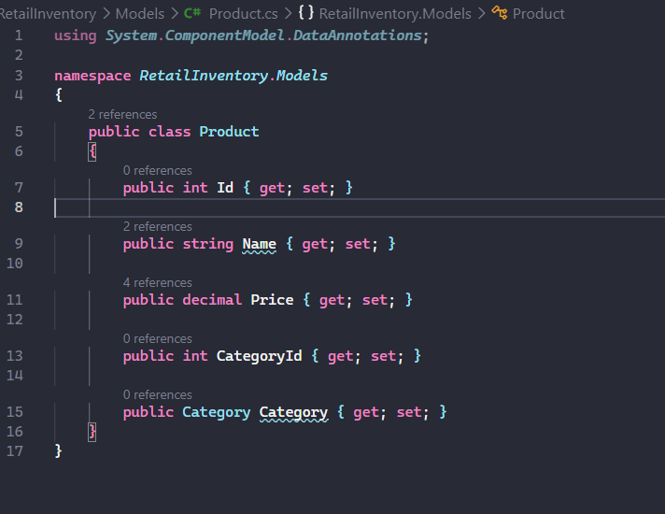
Category.cs
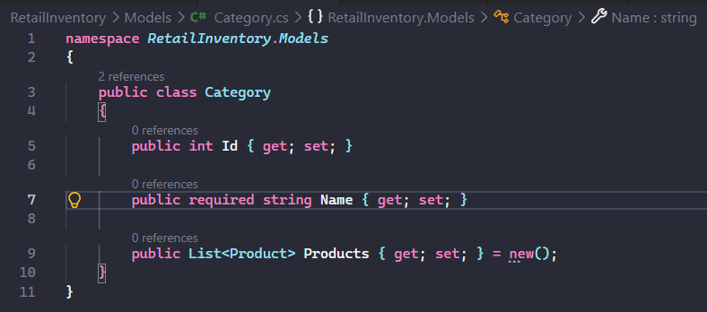
AppDbContext.cs
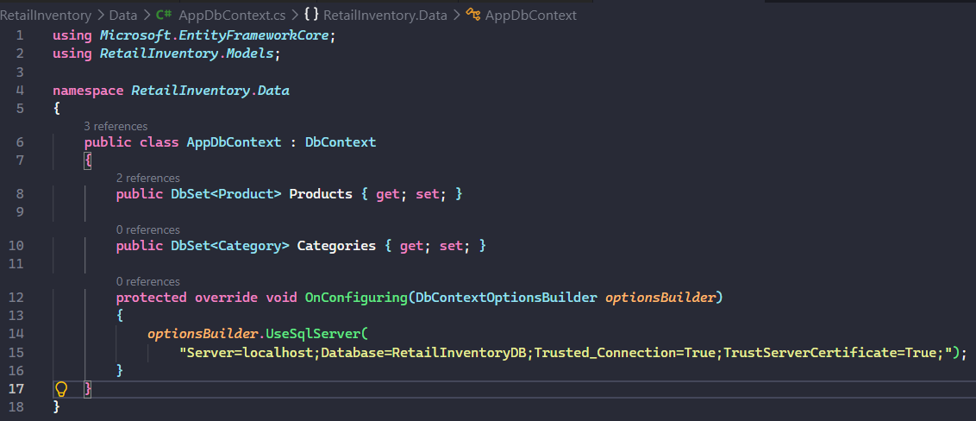
SSMS:
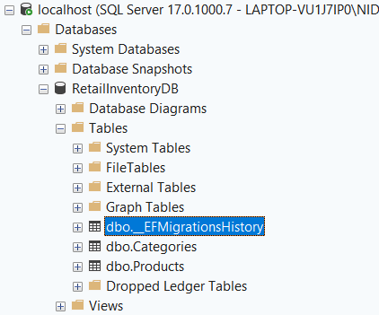
Lab4 :Output
Lab5:Output
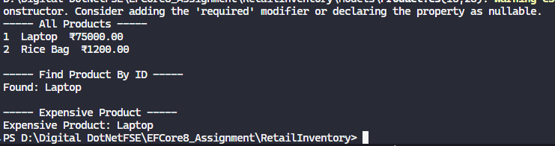
Lab6:Output
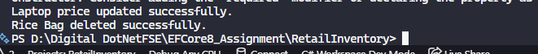
Lab 7:Output
